Amit Machine Learning Training

Task: Error bar in bar plot

BY: Mrwan Medhat Ibrahim

**The Error bar in barplot**

Is the confidence interval which is range of values that you expect your estimate to be in between a certain percentage of the time if you run your experiment again or re-sample the population in the same way.

Simply is the [mean](https://www.scribbr.com/statistics/mean/) of your estimate plus and minus the variation in that estimate

For example, if you construct a confidence interval with a 95% confidence level, you are confident that 95 out of 100 times (alpha=5 times) the estimate will fall between the upper and lower values specified by the confidence interval



a : is the threshold for [statistical significance](https://www.scribbr.com/statistics/statistical-significance/) ,In most cases, researchers use an alpha of 0.05, which means that there is a less than 5% chance that the data being tested could have occurred under the null hypothesis.

In python seaborn confidence interval (ci) defult is 95% and can be changed by typing ci= value

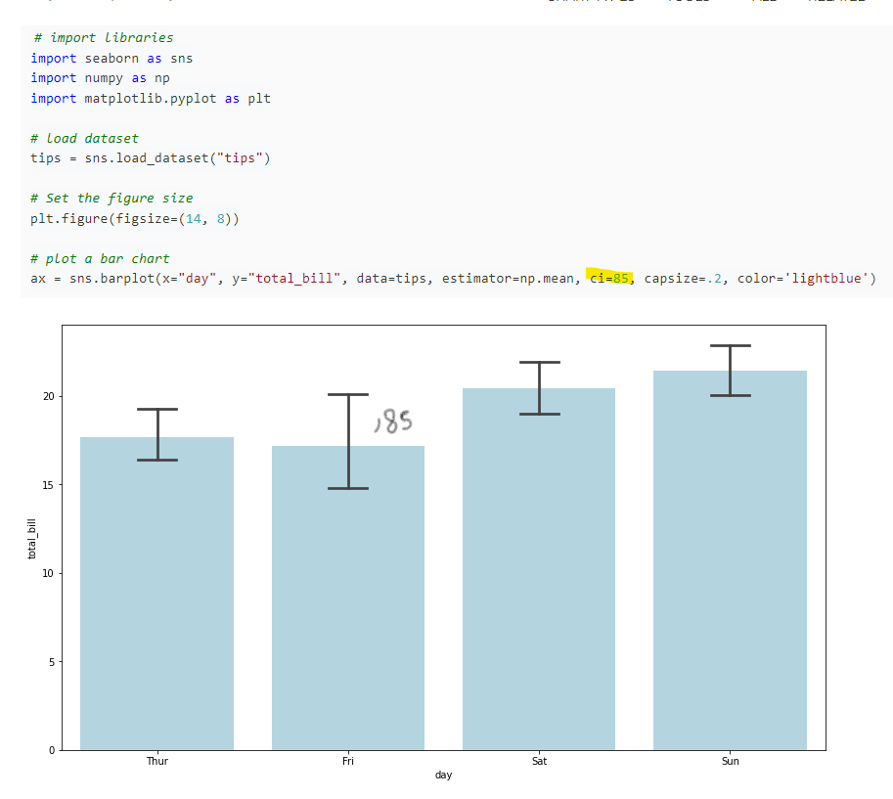

**Reference**

**<https://www.scribbr.com/statistics/confidence-interval/>**

**<https://www.python-graph-gallery.com/error-bars-on-barplot>**

**<https://blogs.sas.com/content/iml/2011/10/07/creating-bar-charts-with-confidence-intervals.html>**

**<https://www.census.gov/programs-surveys/saipe/guidance/confidence-intervals.html>**

**<https://www.youtube.com/watch?v=tFWsuO9f74o>**

**<https://www.youtube.com/watch?v=hlM7zdf7zwU>**